Contents

INTRODUCTION: 2

AIM: 2

THEORY: 2

Transducers 2

Actuators 2

Amplifier 2

Oscillator 2

Wheatstone Bridge 3

Strain Gauge 4

LVDT: Linear Variable Differential Transformer 5

Equipment Specification: 6

OBSERVATION AND CALCULATION: 7

WHEATSTONE BRIDGE EXPERIMENT 7

STRAIN GAUGE EXPERIMENT 7

LINEAR VARIABLE DIFFERENTIAL TRANSFORMER (LVDT) EXPERIMENT 7

GRAPH: 8

COMPARISION WITH THEORY: 9

WHEATSTONE BRIDGE EXPERIMENT 9

STRAIN GAUGE EXPERIMENT 9

LINEAR VARIABLE DIFFERENTIAL TRANSFORMER EXPERIMENT 9

CONCLUSION AND DISCUSSION: 9

ADDITIONAL DISSCUSSION: 10

Sensors 10

Resolution 10

Bandwidth 10

Transfer Function 10

Sensitivity 10

Linear and Non-Linear Function 10

Response Time 10

Offset 10

Differentiating Amplifier 10

Summing Amplifier 11

Inverter 11

Comparator 11

Full Wave Rectifier 11

Converter 11

Some other terminologies 11

REFRENCES: 11

## INTRODUCTION:

An **instrumentation trainer** is an educational kit for learning measurement and control systems, featuring transducers, signal conditioning, and calibration tools. A **transducer** converts physical quantities (e.g., temperature, pressure) into measurable signals. Together, they teach automation, electronics, and control engineering concepts, enabling hands-on training for industrial and academic applications.

## AIM:

To explore the principles of resistance measurement using a Wheatstone Bridge, study the working and applications of a strain gauge transducer, and investigate the characteristics and functionality of a Linear Variable Differential Transformer (LVDT) through practical implementation using an instrumental trainer and transducer setup.

## THEORY:

Transducers  
A transducer converts one form of energy into another. Types include input transducers (sensors) that convert physical energy into electrical signals (e.g., thermocouples) and output transducers (actuators) that convert electrical energy into physical motion (e.g., motors). They are used in industries, medical fields, and consumer electronics.

Actuators  
Actuators convert electrical energy into physical motion, with types including electric, pneumatic, and hydraulic actuators. They produce linear, rotary, or oscillatory motion and are used in robotics, automation, and industrial systems. Key characteristics include power output, speed, precision, and efficiency.

### Amplifier

An amplifier boosts a weak signal’s power, voltage, or current. Types include voltage, current, and power amplifiers, with operational amplifiers used in analogy processing.

Classes range from Class A (high fidelity, low efficiency) to Class D (efficient digital amplifiers). Key features are gain, bandwidth, distortion, and impedance matching.

### Oscillator

An oscillator is an electronic circuit that generates periodic signals like sine, square, or triangular waves by converting DC into AC using positive feedback to sustain oscillations. It meets the Barkhuizen Criterion (loop gain = 1, phase shift = 0°/360°) and is classified into LC, RC, crystal, and relaxation types, each suited for specific frequency ranges. Oscillators are essential in communication, timing, audio, and signal testing applications due to their stability, consistency, and low noise. Alarm oscillator is a circuit having an input and an output, with the input magnitude below a certain level, the out is zero, when the input exceeds the threshold, the output is a n alternating voltage. A circuit allowing signals over a selected range of frequencies to pass while blocking the passage of signals at both lower and higher frequencies is band pass filter.

### Wheatstone Bridge

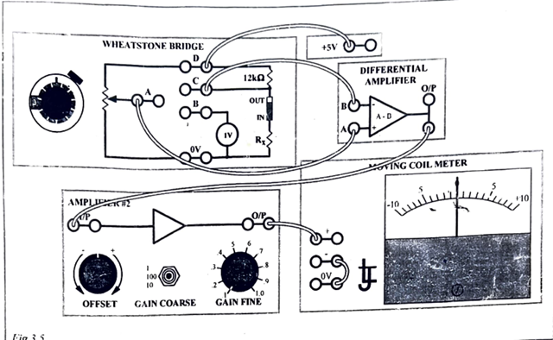

The Wheatstone bridge is a circuit used for precise resistance measurement. It consists of four resistors arranged in a diamond shape, with a galvanometer connected across the bridge to detect current. Two resistors have fixed values, one is an unknown resistance (Rx), and the fourth is a variable resistor adjusted to achieve balance. The bridge is balanced when no current flows through the galvanometer, which occurs when the ratio of resistances in one branch equals the ratio in the other, expressed as R1/R2=Rx/R3. From this, Rx can be calculated accurately. Thus, the resistance R1 and R2 are called ratio arms of bridge. A potentiometer is a variable resistor with three terminals, allowing for adjustable voltage or resistance. It is often used in circuits like the Wheatstone bridge, where it helps balance the bridge by adjusting resistance, providing accurate voltage measurements. The wiper of the potentiometer moves across the resistive element to vary the resistance, enabling fine control in applications requiring precise adjustments.

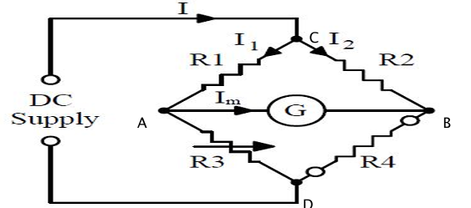

### Strain Gauge

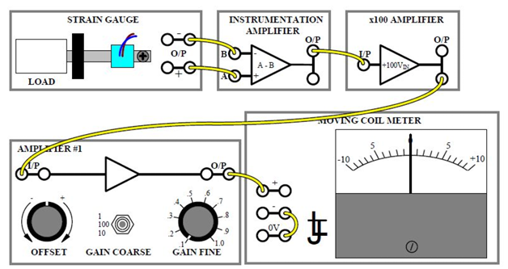

The resistance RR of a metal wire is given by R=liar = \rho \cot \frac{L}{A}, where ρ\rho is resistivity, LL is length, and AA is the cross-sectional area. Stretching the wire increases its length and reduces its area, raising the resistance, while compression shortens and thickens the wire, lowering resistance. Slight changes in resistivity also occur due to structural modifications during stretching or compression. Strain gauges, made of thin wires, are glued to structures to detect resistance changes caused by strain, enabling measurement of structural deformation, such as in oil rigs or aircraft wings. The change in resistance ∆R in a strain gauge of resistance R is very nearly proportional to the applied strain. Hence:

Here K is gauge factor and Ɛ is relative strain. The gauge subjected to loading is active and the other is called dummy loading.

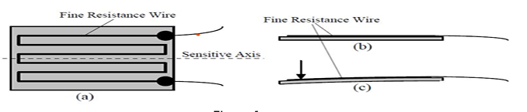

### LVDT: Linear Variable Differential Transformer

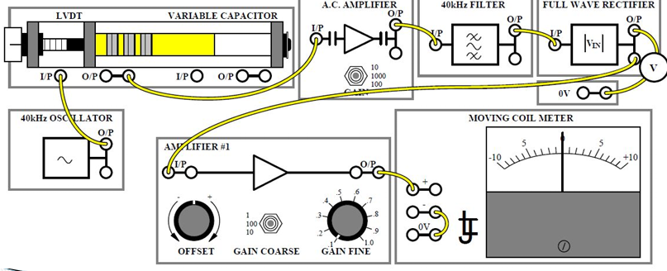

A Linear Variable Differential Transformer (LVDT) is an electrical transformer used to measure linear displacement. It operates on the principle of mutual induction, converting non-electrical displacement into electrical energy. The LVDT consists of a cylindrical former with one primary winding at the centre and two secondary windings on either side. The secondary windings are identical but wound in opposite directions, so the output voltage is the difference between their voltages: Voit=V(A)−V(B). An iron core, capable of linear motion, is placed at the centre of the cylindrical former. The operating frequency of the LVDT typically ranges from 50 to 400 Hz.

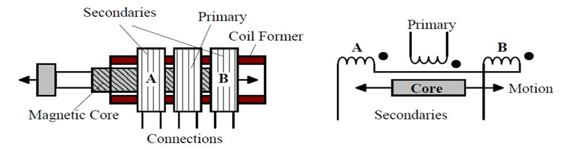

The LVDT operates in three cases based on the core's position. In Case 1, when no displacement occurs, the induced voltages in both secondary coils are equal, resulting in zero output. In Case 2, when the core moves left, the voltage in coil A becomes higher than in coil B, generating a positive output in phase with the input. In Case 3, when the core moves to the right, the voltage in coil B exceeds that in coil A, producing a negative output that is out of phase with the input.

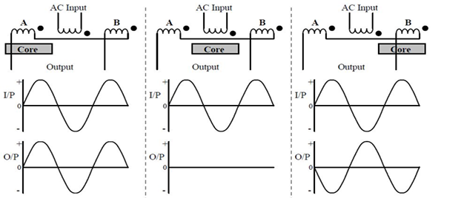

## Equipment Specification:

A transducer is a device that converts one form of energy into another, typically converting physical quantities like temperature, pressure, or displacement into electrical signals. Common types include thermocouples, strain gauges, and LVDTs. An Instrumentation Trainer is an educational tool used to demonstrate the operation and working principles of various transducers and measurement systems. It includes components like sensors, amplifiers, and signal processing units, helping students understand how instruments are used in real-world applications for precise measurement and control in industries.

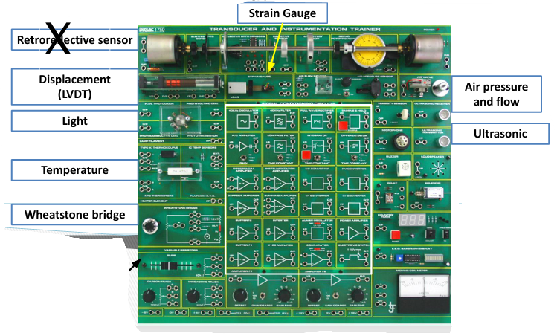

## OBSERVATION AND CALCULATION:

### WHEATSTONE BRIDGE EXPERIMENT

DIAL READING= 200

R1 = 200 x 10 = 2000 Ω

R2 = 10000 – R1 = 10000 – 2000 = 8000 Ω

R3 = 12000 Ω

Substituting values in formula we get,

R4 = .R1 = .2000 = 3000 Ω

### STRAIN GAUGE EXPERIMENT

|  |  |  |  |  |  |  |  |  |  |  |  |
| --- | --- | --- | --- | --- | --- | --- | --- | --- | --- | --- | --- |
| **No. of Coins** | **10** | **9** | **8** | **7** | **6** | **5** | **4** | **3** | **2** | **1** | **0** |
| **Output Voltage** | 7.0 | 6.0 | 5.5 | 4.5 | 4 | 3.5 | 2.5 | 2 | 1.5 | 0.5 | 0.0 |

### LINEAR VARIABLE DIFFERENTIAL TRANSFORMER (LVDT) EXPERIMENT

|  |  |  |  |  |  |  |  |  |  |  |
| --- | --- | --- | --- | --- | --- | --- | --- | --- | --- | --- |
| **Core Positions** | | **-4** | **-3** | **-2** | **-1** | **0** | **1** | **2** | **3** | **4** |
| **Output Voltage** | **Analog Meter** | 0 | -1 | -2.5 | -5 | -7.5 | -5 | -2.5 | -0.5 | +0.5 |
| **Digital Meter** | 4.1 | 3.2 | 1.0 | 0.3 | 0.2 | 0.2 | 1.0 | 3.5 | 4.5 |

## GRAPH:

**B) Output voltage varying as per load applied on staring gauge**

**C) Output voltage observed on analogy and digital meter with Core position**

## COMPARISION WITH THEORY:

As we learned from the theory, we always calibrate the circuit by adjusting both the coarse and fine gain values. Only after this calibration do we perform the experiment to achieve the most optimal results.

### WHEATSTONE BRIDGE EXPERIMENT

Based on the theory, we can analyse that there is no deflection in the galvanometer when the unknown resistor reaches a specific value, determined by the readings from the potentiometer and the fixed 12,000-ohm resistor. Since the signals from the Wheatstone bridge are quite small due to the high resistance values, amplifiers are used to enhance these weak signals. As discussed in the theory, amplifiers serve to boost these low-level signals for clearer and more accurate measurement.

### STRAIN GAUGE EXPERIMENT

As we learned from the theory of strain gauges, these devices detect force by converting the applied load into an electrical signal, making them transducers. When a load is applied to the strain gauge, it causes the resistance of the thin wire to increase, thereby reducing the signal passing through the gauge. Since the output signals are typically very weak, amplifiers are used to boost these signals, leveraging their ability to amplify low-level signals for accurate measurement and analysis.

### LINEAR VARIABLE DIFFERENTIAL TRANSFORMER EXPERIMENT

The LVDT (Linear Variable Differential Transformer) is a type of transducer, but it can also be considered a transformer, as it converts the physical motion of the core into an electrical signal, which can be measured using an oscilloscope. Since the electrical signal is generated by magnetic induction, it functions like a transformer. Due to disturbances and variations in the frequency range from the LVDT, filters are used to allow only specific frequency ranges to pass for analysis. In this setup, the input is an alternating signal, but since the oscilloscope measures direct signals, a rectifier is used to convert the alternating current (AC) signal to direct current (DC) for accurate measurement.

## CONCLUSION AND DISCUSSION:

In this experiment, we learned how to use the instrumentation trainer and transducer equipment, focusing on three main experiments: Wheatstone Bridge, Strain Gauge, and Linear Variable Differential Transformer (LVDT). This trainer is an effective learning tool, equipped with various sensors, amplifiers, transducers, rectifiers, and other electronic components commonly used in circuits. The Wheatstone Bridge circuit is highly sensitive, detecting minute changes in resistance, making it ideal for sensor calibration. Strain gauges change their resistance when a load is applied, providing a significant resistance variation even with a small force, allowing for load measurement via voltage. The LVDT, a type of transformer, measures the displacement by comparing the signals induced in two coils as a common core moves through them. All these components are sensitive and useful for calibrating precise sensors and electronic devices.

## ADDITIONAL DISSCUSSION:

Sensors  
Sensors detect physical quantities like temperature, pressure, and light, converting them into electrical signals. Key features include sensitivity, accuracy, resolution, and range, making them vital in automation, medical devices, and environmental monitoring.

Resolution  
Resolution is the smallest detectable change in measurement, affecting sensor accuracy and system performance in displays, imaging, and data processing.

Bandwidth  
Bandwidth is the range of frequencies a system can transmit or process, impacting data transfer speed and performance in communication networks and signal processing.

Transfer Function  
A transfer function represents the input-output relationship of a system in the frequency domain, aiding in the analysis of stability, frequency response, and dynamic behaviour. It is used in control systems, signal processing, and electrical circuits.

Sensitivity  
Sensitivity is the ratio of a device’s output to the magnitude of its input. A highly sensitive device detects small input changes.

Linear and Non-Linear Function  
A linear function maintains a constant ratio between two quantities, whereas a non-linear function does not. Linearity measures how much a system’s output deviates from an ideal straight-line response within the same measurement range.

Response Time  
Response time is the duration for a system's output to reach or fall within a specified percentage of a new final value after an input change. Faster response times are essential for real-time applications.

### Offset

Offset in electronics is a constant deviation from the ideal value caused by factors like component tolerances and temperature changes, leading to signal distortion and measurement errors. Mitigation includes adjustment, compensation circuits, or calibration to ensure accuracy in amplifiers, measurement devices, and communication systems.

### Differentiating Amplifier

A differentiator amplifier is an op-amp circuit that outputs a signal proportional to the input's rate of change, highlighting high-frequency components. It amplifies fast input changes with an inverted output and is used in signal processing, edge detection, filtering, and control systems. However, it is sensitive to noise, has bandwidth limits, and may saturate at rapid input changes. Proper design requires careful selection of resistor and capacitor values and ensuring feedback loop stability.

### Summing Amplifier

A summing amplifier combines input signals into a weighted sum, usually inverting the output. It is used in audio mixing, signal processing, and analogy computing. The output depends on feedback and input resistors, considering resistor selection, impedance matching, and op-amp choice. Limitations include noise sensitivity and power supply constraints.

### Inverter

An inverter reverses signal phase, amplifies inputs in inverting amplifiers, converts DC to AC in power inverters, and adjusts phase in audio systems for effects like noise cancellation. Both inverters and amplifiers are crucial for signal shaping in audio mixing and power conversion.

### Comparator

A comparator compares two voltages and outputs a digital signal based on which is higher. It operates with high gain and fast switching, used in zero-crossing detection, PWM, ADCs, and switching circuits. Types include window comparators, Schmitt triggers (with hysteresis), high-speed, and low-voltage versions. Despite challenges like noise and power consumption, comparators are vital for signal conditioning and control systems.

### Full Wave Rectifier

A full-wave rectifier converts AC to pulsating DC using both cycles for higher efficiency and smoother output. It can operate in centre-tap (two diodes) or bridge (four diodes) configurations. The output, at twice the input frequency, can be smoothed with filters like capacitors. Full-wave rectifiers are efficient, produce less ripple, and are used in power supplies, battery chargers, and devices requiring steady DC voltage.

### Converter

Converters change electrical power forms: AC to DC (rectifiers), DC to AC (inverters), DC to DC (buck, boost, buck-boost), and AC to AC. Rectifiers provide DC for devices, inverters supply AC for solar and UPS systems, DC to DC converters adjust voltage in portable devices and EVs, and AC to AC converters modify voltage/frequency for industrial drives and grids, enabling efficient power management across applications.

### Some other terminologies

An integrator outputs a voltage proportional to the input voltage over time, while a differentiator outputs a voltage proportional to the rate of change of the input voltage. In a sample state, the output voltage matches and tracks changes in the input. In a hold state, the output voltage remains fixed at the input signal's value when the hold signal is activated.

## REFRENCES:

* <https://pratikgoswami.weebly.com/uploads/1/1/0/9/11090116/emi_lab_manual_-_ld_college__1_.pdf>
* <https://www.studocu.com/in/document/delhi-technological-university/measurements-instrumentation/transducer-lab-manual/44772509>
* <https://mineinstruments.com/wp-content/uploads/2023/08/MI-IN02-LVDT-Trainer.pdf>
* <https://infinit-technologies.com/product/it-5927-transducer-instrumentation-trainer/>